Guidance notes

Contents
Page 2-4 Referral Process
Page 4 Supporting Documents Required
Page 5 Spot Purchasing YCS Beds
Page 5 Feedback from Secure Children’s Homes
Page 5 Referral Acceptance
Page 5 Updated Referrals
Page 6-7 Statement of responsibility
Page 8-11 FAQs
Page 11 Glossary
Page 12 Contact Details
Page 13 Referral Process Flowchart
Page 14 Under 13 Referral Process Flowchart
Page 15 Out of Hours Under 13 Referral Process Flowchart
Page 16 Mock Referrals

Referral Process
The process outlined below has been created through working closely with the secure homes in England and Wales and, therefore, all the information requested is reflective of what is required for a secure home to make an informed decision on whether they’re able to accept a referral.
All referrals should be submitted through the Secure Welfare Coordination Unit’s (SWCU) online portal which can be accessed here: Secure Accommodation Network
For further information and guidance please contact the SWCU directly via email (securewelfare@hants.gov.uk) or call on 01962 846432.
A profile will need to be set up by the referring social worker via the SWCU portal. This requires two-step authentication using a mobile app.
Once your profile has been created you can start a new referral. Several points of contact will be required; however, the profile owner will be responsible for completing amendments and updates to the submitted information.
Once the form has been submitted to the SWCU, an acknowledgement receipt will be sent within 30 minutes. If an acknowledgement email has not been received within 30 minutes, please contact the SWCU via phone or email.
A member of the SWCU will then screen the referral to outline if any further information is required. If further information is required, you will receive a notification email and amendment requests will appear on your referral form on the online portal. The SWCU has taken learning from the secure children’s homes to identify what information they require when considering referrals. Therefore, the quality and the context of the referral form is required to be comprehensive to support the referral process. The SWCU are unable to make a referral live until all the relevant sections have been completed. Supporting documents will be required to be uploaded to the online portal alongside the completed referral form: (Supporting Documents Required)
If the young person is under 13 years of age, Secretary of State (England)/Welsh Ministerial (Wales) approval is required to place them in a secure welfare home. It will be expected that a secure welfare referral is submitted to the SWCU in parallel to the Secretary of State/Welsh Ministerial application, once the referral and application have been completed and agreed a secure welfare search can be undertaken. The local authority will need to liaise directly with the Department for Education (England)/Welsh Government (Wales) regarding this. A section 25 secure order or Assistant Director’s 72-hour placement agreement is still required even once Secretary of State/Welsh Ministerial approval/consent is granted. Further information on applying for Secretary of State/Welsh Ministerial approval can be found on the Secure Accommodation Network (SAN) website and the government website:

Secure Accommodation Network
England Government Guidelines U13
Wales Government Guidelines U13 (English)
Under 13 Flowchart
Out of hours – Under 13 Flowchart
Wales Government Guidelines U13 (Welsh)

Once all the necessary information is present on the referral form, it will become a ‘live’ referral with the SWCU. It will then be made available to all secure children’s homes for their consideration. Local authorities with ‘live’ referrals will receive an email with the updated projected bed vacancies each day. The secure children’s homes will inform the SWCU of the date and gender of their next available bed in advance. This allows the homes time to consider all live referrals and offer a planned transition for young people. The identification of the secure children’s homes will not be released at this point in the process. The projected beds are subject to change and the local authority will be updated of any changes throughout the working week.
If a secure home feels they can accept a referral they will contact the SWCU, who will, in turn, call the local authority to inform them which secure home is offering a bed for their young person. The SWCU will also send a confirmation email to the local authority, this will include the contact name, number and address of the home. The local authority will be required to accept the bed offer within three working hours, else the bed offer may be rescinded and re-offered to the next suitable placement.
Once a bed is accepted it is then the responsibility of the local authority to contact the secure home to discuss costs, admission date/time and the signing of any paperwork. Secure homes will be unable to admit a young person until they have received signed copies of all the relevant paperwork.
The SWCU are not part of the decision-making process and are therefore unable to prioritise individual referrals. All live referrals will be made available to all secure homes with appropriate vacancies. If the local authority believes that the young person has an imminent and significant risk to their life, then they are advised to call the SWCU and update them of such in the first instance.
Young people can only have their liberty restricted in a secure setting if either a section 25 secure order has been granted by the courts or if an Assistant Director has agreed to place the young person under a 72-hour placement. If a young person has already been placed for 72 hours under this agreement, within a 28-day period, then a secure order will need to be applied for through the court. It will need to be granted before the young person can be placed for any further time within the secure welfare estate.
Please see page 13 for the referral process Flowchart.
From the experience gained working with the secure homes in England and Wales, the SWCU has created three mock referrals which can be used as a basis to help with the referral process. The mock referrals are fabricated and have been based on the SWCU’s knowledge of the referral process and the expectations required by the secure children’s homes, to support them making an informed decision on placements. Links to these documents can be found on page 16.
Supporting Documents
Additional information will be required on certain aspects of a referral, therefore, through discussions with the secure homes, a list of proposed supplementary documents has been drawn up (please see below). These documents are in addition to the referral and can’t be used to replace sections of the referral form being completed. Please note: If the young person has an EHCP, this will be required to be uploaded before the referral can be made ‘live’.
Documents required:

- Chronology
- Mental Health Assessment i.e. CAMHS, etc.
- Health Assessments
- Offending information
- Daily logs from their current residential or secure placement
- Care Plan
- Recent/previous minutes of meetings i.e. CIN plan, S47 strategy discussions etc
- EHCP
- Asset Plus

Spot Purchasing YCS beds
In exceptional circumstances the SWCU can approach the Youth Custody Service (YCS) to discuss the spot purchasing of a bed from the youth custody estate for the purposes of welfare. These requests can only be processed through the SWCU. Contact should be made with the SWCU in the first instance, to discuss whether this is a viable option for your referral. Requests will need to be made in writing to the SWCU.
Feedback from Secure Homes
The SWCU requests that feedback from the secure children’s homes is provided. When feedback is received, it will be provided to the local authority in a timely manner. The ability for the SCH’s to provide feedback is purely dependent on the homes’ capacity and there is no obligation for this to be provided.
Referral Acceptance
As the SWCU is not a commissioning unit, the unit are unable to direct a secure home to accept a referral, the decision to accept a referral rests solely with the secure home.
Updated referrals
The SWCU will request an updated referral every two weeks to reflect an overview of the young person’s current situation, if a referral is no longer required please inform the unit. However, if an updated referral is not received within the given timeframe the search will cease with the unit. Local authorities will be made aware if their secure search has been ceased and their referral closed to the SWCU.

Statement of responsibility:
The Secure Welfare Coordination Unit (SWCU) is a small unit grant funded by the Department for Education (DfE) for the purposes of administering placements and collecting data on secure welfare. It is not a legal entity and therefore does not have a Director. The SWCU provides a transparent, dedicated single point of contact for local authorities in England and Wales, to arrange secure welfare placements and streamline the process of finding the most suitable placement matching the individual needs of each young person needing secure care. The SWCU is committed to ensuring the best outcomes for all children needing secure placements. Data from the Secure Children’s Homes is collected by the SWCU daily. Referrals are then made available to homes if a projected secure place is available. The home will then indicate whether they can accept the young person.
Neither the Secure Welfare Coordination unit, nor the Secretary of State has a direct role in the commissioning of secure places for individual young people on welfare grounds. It is for the local authority to come to a view as to the appropriate placement for an individual child, and for the person with management responsibility for the Secure Children’s Home with available places to decide whether to take the child. Under The Children’s Homes Regulations (England) Regulations 2015, (Regulation 14(2)(a)) – the registered person (i.e. the provider of the home) must ensure that children are admitted to the home only if their needs are within the range of needs of children for whom it is intended that the home is to provide care and accommodation, as set out in the homes statement of purpose. A secure home will therefore consider the existing cohort of young people in their care, their needs, the skills and ability of the staff to manage and meet their needs when considering any new application.
Individual local authorities should have their own placement policy based on the Department for Education’s Care Planning Placement and Case Review (England) Regulations 2010. There are currently 13 secure children’s homes (SCHs) in England – 12 run directly by the local authorities in which they operate; one run by a charity. The SCHs take referrals from local authorities across the country seeking a secure placement under section 25 of the Children Act 1989, and also provide accommodation for some children who have been found guilty of crimes and given a custodial sentence. The final decision on making a welfare placement remains with the placing local authority and the manager of the receiving secure children’s home.
While there is no absolute duty to provide secure accommodation in their area, there are general duties on local authorities to provide accommodation for looked-after children. In particular, section 22G of the Children Act 1989 imposes a duty on each local authority to take steps that ensure so far as reasonably practicable that they are able to provide accommodation in their area that meets the needs of children who are looked after by that local authority and fall within the section 22G(3) criteria. This is commonly known as the ‘sufficiency duty’. In taking steps to secure that outcome the local authority must have regard to the benefit of having a number and range of accommodation providers that is, in their opinion, sufficient and capable of meeting different needs. Statutory guidance has been issued on securing sufficient accommodation for looked after children.
A major benefit of the SWCU is that detailed information from all the Secure Children’s Homes in England and Wales and the young people placed in them will be held in one place. This has the advantage of ensuring that all options for a young person can be considered enabling informed decisions about the most appropriate placement for them. This much-needed data will prove invaluable in terms of learning what is working and where changes may be needed. We will also be building national profiles for England and Wales on the young people referred including complexities and needs.
The Secure Welfare Coordination Unit will maintain up to date availability information across all Secure Children’s Homes providing secure welfare care. The centralised unit will also be able to gain a much clearer understanding of the volume, demand and need profile of young people needing secure welfare accommodation. The SWCU will collect data on all aspects of referrals for young people and the outcomes of those referrals, including where there have been challenges to making placements. This coordinated information will be shared with the sector for its strategic development and will ultimately support Ministers to make decisions on the future of the sector.

FAQs
How do I find out if there are any secure beds available and/or where our referral has been sent?
The SWCU receives vacancy forms from all secure homes with welfare beds, in England and Wales, each weekday morning. Under the projected beds process, the SWCU will be aware of projected bed availability by approximately 10am. The process ensures that the secure children’s homes inform the SWCU of the date and gender of their next available bed in advance. This allows the homes time to consider all ‘live’ referrals and offer a planned transition for the young person. The identification of the secure children’s homes will not be released at this point in the process. These projected beds are subject to change and the local authority will be updated of any changes throughout the working week.
All ‘live’ referrals will be made available to the secure homes with appropriate vacancies and the SWCU will email these local authorities, each morning, with an update on the projected beds in the estate.
If you do not receive an update, or if you are still unsure as to the status of your referral, please contact the SWCU by phone and an update can be given to you verbally.
If I do not have a ‘live’ referral, how do I find out if there are any projected welfare vacancies?
Even without a ‘live’ referral the SWCU can provide an update on projected available secure welfare beds, you do not need a ‘live’ referral to request this information. This information will be provided to you in the form of the gender of the beds and dates that they are available from, the identity of the homes will not be available at this point.
Will the SWCU liaise directly with the social worker to discuss a referral?
The SWCU receives referrals from different social care teams dependent on each local authorities’ process, therefore there is no standardised process as to who the SWCU will liaise with. The SWCU recommends that a local authority designates one/two points of contact throughout the process, to maintain clear lines of communication; this usually being the social care and placement team.

What if my referral has not received any feedback when they have been considered?
The SWCU is unable to direct the secure children’s homes to provide feedback for all referrals. As standard practice the SWCU requests feedback and, where capacity allows, the secure homes will provide this to the unit. If you have not received any feedback this does not mean that your referral has not been considered.
Can I contact a secure home directly to find out if they have vacancies?
The SWCU is now the single point of contact for all secure welfare placements in England and Wales. If you contact a home directly, regarding available vacancies, the homes will signpost you back to the SWCU.
If there are no projected welfare vacancies in England or Wales, are there any other options?
If there are no projected welfare beds in the estate, please contact the SWCU in the first instance to discuss your referral or intent to refer, as the unit will be able to provide an overview of sufficiency in the estate at that time.
Can we place a young person in a Scottish secure children’s home under a section 25 secure order?
Yes, as of April 2017, a section 25 secure order is now recognised by the courts in Scotland. Contact with the SWCU will still be required in the first instance and advice can be given regarding the process of placing in Scotland. Unlike residential cross border placements in Scotland, a young person’s permission is not required to place them in a Scottish secure children’s home. Scottish secure childrens homes will prioritise Scottish referrals in the first instance, therefore there is likely to be limited capacity in the Scottish estate.
Can we make a referral for a young person if they are missing?
Yes, you can make a referral for a young person who is missing, but a retainer will need to be agreed by your management team before a referral can be made ‘live’; preferably, this should be agreed before the referral is submitted.
The price of a retainer will typically be of the full cost of a secure home’s daily fee. This will need to be discussed with the secure home once the young person has been offered a bed.
How do I gain Secretary of State (England)/Welsh Ministerial (Wales) approval to place a young person under the age of 13?
You will need to contact the DfE/Welsh Government to discuss secure accommodation for a young person under the age of 13.
Further information, on how to make an application to DfE/Welsh Government, can be found on the SAN website and the government website:

Secure Accommodation Network
England Government Guidelines U13
Wales Government Guidelines U13 (English)
Under 13 Flowchart
Out of hours – Under 13 Flowchart
Wales Government Guidelines U13 (Welsh)

Should a referral be submitted on the day a local authority is in court to gain a section 25 order?
The SWCU recommends you do not submit a referral on the day of a court hearing, with the view of placing the young person in secure accommodation on the same day. Though there may be occasions where this is unavoidable.
The process of ensuring all the relevant information is present on the referral can be extensive, due to the volume of information and context the secure children’s homes require. Also, there may not be any available welfare vacancies on the day in question.
If a section 25 order is granted before a secure welfare bed has been identified, this will not prioritise the referral.
What if I require a secure welfare bed outside of the unit’s working hours, for an urgent referral that is not already ‘live’ with the unit?
The SWCU’s working hours are Monday – Friday 8.30am – 5.00pm. Outside of the unit’s working hours, you will be able to find contact details for each of the secure children’s homes on the SAN website, Secure Accommodation Network. It will be a local authority’s responsibility to contact the homes directly out of hours. If a placement is made a referral to the SWCU will still be required.
However, please bear in mind that if you contact a secure children’s home during working hours, then you will be redirected back to the SWCU.
What happens if I no longer require a secure welfare search to be undertaken once a referral is ‘live’ with the unit?
Please contact the SWCU via email or phone if a search is no longer required due to a change in the young person’s situation or care planning, a search will then cease by the unit. It is requested that the unit are made aware of any changes in circumstance, to avoid the secure homes looking at referrals unnecessarily.
The unit will undertake weekly calls to the referring social worker where capacity allows, to ensure the referral is still required and accurately reflects the young person’s current circumstances, please inform the SWCU during this call if a search is no longer required.
The SWCU will request an updated referral every two weeks to reflect an overview of the young person’s current situation, if a referral is no longer required please inform the unit. However, if an updated referral is not received within the given timeframe the search will cease with the unit.
Glossary
Term | Meaning
Section 25 | Secure order granted by the court
SWCU | Secure Welfare Coordination Unit
SCH | Secure Children’s Home
YCS | Youth Custody Service (Formerly the YJB – Youth Justice Board)
DfE | Department for Education
72-hour placement | When an Assistant Director agrees for a young person to be placed in secure accommodation for an initial period of 72 hours and, thereafter, go to court for a secure order.
A retainer | The cost to hold a bed if a young person is missing/waiting an admission
Out of Hours (OOH) | Outside of the unit’s working hours Monday - Friday 8.30 – 5.00

Contact Details
Secure Welfare Coordination Unit
Hampshire County Council
Hampshire County Council,
Elizabeth II Court North,
The Castle,
Winchester
SO32 8UG
Tel: 01962 846432
Secure Email Address: securewelfare@hants.gov.uk

Service Lead Manager: Helen Gunniss
The SWCU team:
- Chris Bayly
- Sarah Hood
- Megan Attwell
- Sam Russell
- Steph Browning
- Georgina Hiller
- Jennifer Nunes Pais
- Olivia Hall

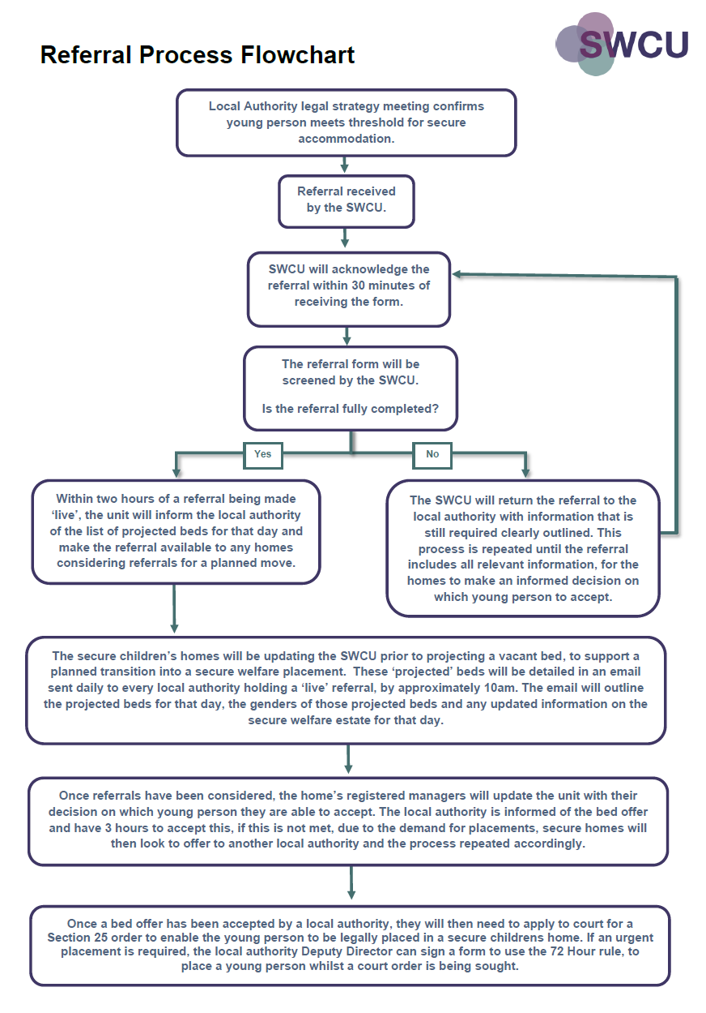
Under 13 Referral
Secretary of State Approval is still required for children placed out of jurisdiction i.e. Scotland.
Yes
No
Complete the SWCU Referral form.
Secretary of State for Education approval is required before the referral can be considered by a secure home. You will need to apply for this alongside completing the standard secure welfare referral.
Applying for SOS Approval
Ensure you have all the required documentation to hand. Details of this can be found here: Guidance
Call the DfE secure children’s homes policy team:
0208 142 5218
(Mon-Fri 9am-5pm)
The DfE will require the following information:
- The name and date of birth of the child you wish to place in a SCH.
- The reasons why you believe a SCH is the right placement and why the child meets S.25 criteria.
- Confirmation of whether you have identified an available bed in a SCH.
- Confirmation of whether the child is currently with you or whether they are missing from care.
- Details of when you intend to go to court to seek a secure accommodation order for the child.
- Details of the alternatives to a secure placement you have considered and why you think a secure placement is necessary.
- Confirmation of whether you have approached the Secure Welfare Co-ordination Unit (SWCU) to submit your referral.
The DfE will then email you a checklist of the documentation required to make the referral and provide you with the U13 email address.
The required documentation is then emailed to the U13 email address provided by the DfE.
Guidance
The DfE will review the documentation, assess the application and advise of the decision as soon as possible. The LA will receive a certificate via email to confirm that the SoS approves the secure placement.
SoS approval will remain valid for 28 days, after which time the LA will need to submit a new application seeking SoS approval if a placement has not been found within 28 days.
If the child remains under 13 when the placement ceases, the LA will need to seek further approval of the SoS if the LA wishes to extend the placement in a secure children’s home.
The LA is required to review the child’s placement within one month and provide the SoS with documentation of the Secure Accommodation Review i.e. minutes of the review meeting.
Is the child being placed under 13?
Process Flowchart (England)

Out of Hours
Out of Hours
Yes
No
Is a secure welfare placement required for an under 13 outside of core working hours?
(Weekends, Bank Holidays and Mon-Fri after 5pm- 9am)
The U13 process for in hours.
Guidance

Call the DfE secure children’s homes policy team:
0208 142 5218
The ‘on call’ duty officer will require the following information:
- The name and date of birth of the child you wish to place in a SCH.
- The reasons why you believe a SCH is the right placement and why the child meets S.25 criteria.
- Confirmation of whether you have identified an available bed in a SCH.
- Confirmation of whether the child is currently with you or whether they are missing from care.
- Details of when you intend to go to court to seek a secure accommodation order for the child.
- Details of the alternatives to a secure placement you have considered and why you think a secure placement is necessary.
- Confirmation of whether you have approached the Secure Welfare Co-ordination Unit (SWCU) to submit your referral.
Based on the information received, the ‘on call’ duty officer will consider whether the criteria is met and if a secure placement would be appropriate for the young person.
The duty officer will give a verbal approval to the LA on the basis that the required documents are submitted as soon as possible the next working day.
Once DfE assesses the documents, the LA will receive a certificate via email to confirm that the SoS approves the secure placement. Then complete the ‘in hours’ U13 process, a SWCU referral is still required even if the child has been placed:
Guidance
Secretary of State Approval is still required for children placed out of jurisdiction i.e. Scotland.
Under 13 Referral
Process Flowchart

Mock Referrals

..
..

